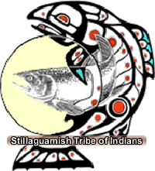 Stillaguamish Tribe
Tribal Services Profile

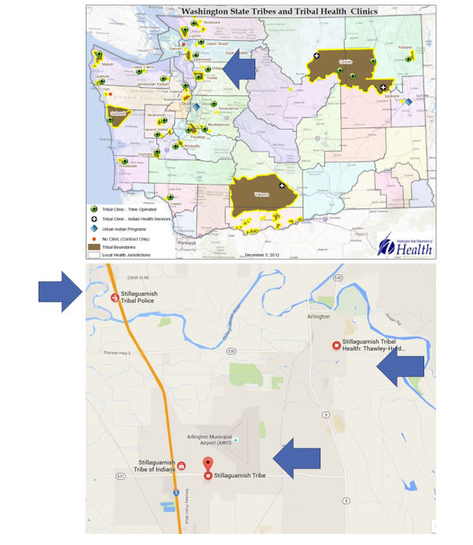

Contents
Reservation (optional) 3
Service Population 3
Medical Services 3
Medical Services List 3
Dental Services 4
Dental Services List 4
Outpatient Mental Health Services 4
Outpatient Mental Health Services List 4
Tribal Crisis Services 5
Tribal Crisis Services 5
Tribal Crisis Coordination Protocol 5
Outpatient Substance Use Disorders Treatment 5
Outpatient SUD Treatment Services List 6
Inpatient Substance Use Disorders Treatment 6
Inpatient SUD Treatment Services List 6
Community Health Services 6
Community Health Services List 6
Social Services (not listed above) 6
Social Services List (not listed above) 7

Reservation (optional)
Land | 64 acres
Boundaries | Snohomish County
Community Structures | - Community Center  - Medical Clinic  - Government Administration Building  - Health Administration Building  - Early Childhood Education Center  - Behavioral Health Center  - Salmon Hatchery  - Gas Station  - Convenience Store  - Casino  - Youth Center
Households | Stillaguamish village project: 5 single family houses, 6 elders cottage units and an elders longhouse which has 6 units.
Total Population | 5*
Population American Indian and Alaska Native | 1*
Population Other Race | 4*
*Information from My Tribal Area website: https://www.census.gov/tribal/ U.S. Census Bureau 2019-2023 American Community Survey

Service Population
Total Service Population | Unknown Currently
Contract Health Services/Purchase and Referred Care Area (Zip Codes) | 98223

Medical Services
Name | Wellness Clinic
Address | 24205 James Dorsey Way Suite A, Arlington, WA 98223
Phone Number | 360.435.9338
Hours of Operation | Mon & Wed 8am-6pm  Tues,Thurs,Fri 8am-4pm  2nd & 4th Saturday 9am-1pm
After-Hours On-Call | N/A
Patient Portal | N/A
Website | https://www.stillaguamish.com/departmentprogramservice/wellness-clinic/
Types of Coverage | Family medicine for tribal members and family, also employees of the tribe
Eligibility | Tribal members and family, other enrolled Native Americans, Tribal Employees
Primary Care Clinic (Title V Compact With IHS) (eligibility) | Yes
Primary Care Clinic (IHS Service Unit) (eligibility) | No

Medical Services List
Wound Care
Medication Management
Home Environment Screenings (for Asthma, Fall Prevention, etc.)
Post-Hospitalization Coordination of Care
Nutrition

Dental Services
Name | N/A
Address | N/A
Phone Number | N/A
Hours of Operation | N/A
After-Hours On-Call | N/A
Patient Portal | N/A
Website | N/A
Specialty Care | N/A
Dental Clinic (Title V Compact With IHS) | N/A
Dental Clinic (IHS Service Unit) | N/A

Dental Services List
N/A

Outpatient Mental Health Services
Name | Behavioral Health Program – Island Crossing Counseling Services
Address | 5700 172nd Street NE Suite B, Arlington, WA 98223
Phone Number | 360.435.3985
Hours of Operation | Monday-Friday 8am-5pm
To make an appointment or inquire about walk-ins | 360.435.3985
Patient Portal | No
Website | https://www.stillaguamish.com/department-listing/behavioral-health-programs/
Culturally-Informed Mental Health Programs | Traditional Arts Therapy, Natural Helpers

Outpatient Mental Health Services – ONLY Stillaguamish Members
Name | Behavioral Health Program - Tribal Mental Wellness
Address | 24306 James Dorsey Way, Arlington 98223
Phone Number | 360.435.3985
Hours of Operation | Monday-Friday 8am-5pm
To make an appointment or inquire about walk-ins | 360.435.3985
Patient Portal | No
Website | https://www.stillaguamish.com/department-listing/behavioral-health-programs/
Culturally-Informed Mental Health Programs | Traditional Arts Therapy, Natural Helpers, Youth and Family Counseling

Outpatient Mental Health Services List
Individual Counseling
Group Counseling
Mental Health Assessment and Diagnosis

Tribal Crisis Services
Name | N/A – Coordinate with Local PD
Address | N/A
Phone Number | N/A
Hours of Operation | N/A
To make an appointment or inquire about walk-ins | N/A
Website | N/A

Tribal Crisis Services
Service | Contact Name | Phone
Tribal Designated Crisis Responder | N/A
Tribal Mobile Crisis Response | N/A
24 Hour Tribal Crisis or Call Line | N/A
Suicide Prevention Coordinator | N/A

Tribal Crisis Coordination Protocol
Is there a Tribal Crisis Coordination Protocol in place?
Yes | No | Link
 | In Progress

Outpatient Substance Use Disorders Treatment
Name | Behavioral Health Program – Island Crossing Counseling Services
Address | 5700 172nd Street NE Suite B, Arlington, WA 98223
Phone Number | 360.435.3985
Hours of Operation | Monday-Friday 8am-5pm
After-Hours On-Call | No
Patient Portal | No
Website | https://www.stillaguamish.com/department-listing/behavioral-health-programs/
Culturally-Informed Programs | Traditional Arts Therapy, Natural Helpers

Outpatient Substance Use Disorders Treatment - OTP- Opioid Treatment Program (Methadone)
Name | Island Crossing Counseling Services
Address | 5700 172nd Street NE Suite A, Arlington, WA 98223
Phone Number | 360.652.9640
Hours of Operation | Office Hours:  Monday-Friday 5:15am-3:30pm  Saturday 5:30am-1pm  Dosing Hours:  Morning 5:30am-11:15am  Afternoon 12:15pm-3:15pm
After-Hours On-Call | No
Patient Portal | No
Website | https://www.stillaguamish.com/departmentprogramservice/island-crossing-counseling-services/
Culturally-Informed Programs | N/A

Outpatient SUD Treatment Services List
Individual Counseling
Intensive Outpatient
Group Counseling
Relapse Prevention
Medication Assisted Treatment
Education Program
DUI Deferred Prosecution Assessments
Other Legal Assessments

Inpatient Substance Use Disorders Treatment
Name | N/A
Address | N/A
Phone Number | N/A
Hours of Operation | N/A
After-Hours On-Call | N/A
Patient Portal | N/A
Website | N/A
Culturally-Informed Programs | N/A

Inpatient SUD Treatment Services List
N/A

Community Health Services
Name | Wellness Clinic
Address | 24205 James Dorsey Way Suite A, Arlington, WA 98223
Phone Number | 360.435.9338
Hours of Operation | Mon & Wed 8am-6pm Tues,Thurs, Fri 8am-4pm 2nd&4th Saturday 9am-1pm
After-Hours On-Call | No
Patient Portal | No
Website | https://www.stillaguamish.com/departmentprogramservice/wellness-clinic/

Community Health Services List
Medical Transports
Immunizations
Diabetes Management Education
Traditional Foods Nutrition Education
Primary Care
Specialty Care Referrals
Vaccines
Laboratory Services
Women’s Health

Social Services (not listed above)
Name | Stillaguamish Tribe Indian Child Welfare
Address | 24322 Di-Out-Sa Arlington, WA 98223
Phone Number | 360.572.3547
Website | https://www.stillaguamish.com/departmentprogramservice/indian-child-welfare/

Social Services List (not listed above)
Program Name | Contact Name | Phone & Email
Family Resources – All Native  24326 Di-Out-Sa  Arlington, WA 98223 | Liya Meyers | Phone: Direct Line: (360)572-3554  Cell Phone: (360)913-2590  Email: lmeyers@stillaguamish.com
Youth Services – Tribal Members Only  24410 55th Ave NE  Arlington, WA 98223 | Justin Tatro | Phone: (360)572‐3044  Email: justintatro@stillaguamish.com
Elders – Tribal Members Only  24304 Di-Out-Sa  Arlington Wa 98223 | Jade Powell | Phone: (360) 631-5591  Email: jpowell@stillaguamish.com
Cultural – Tribal Members Only  3322 236th St NE  Arlington, WA 98223 | Shawn Yanity | Phone: Direct Line: 360-572-3021  Cell phone: 425-359-4182  Email: syanity@stillaguamish.com
Vocational Rehabilitation – All Native  3201 Northwest Ave #8  Bellingham, WA 98225 | Jana Finkbonner | Phone: (360) 671-7626  Email: jfinkbonner@stillaguamish.com

