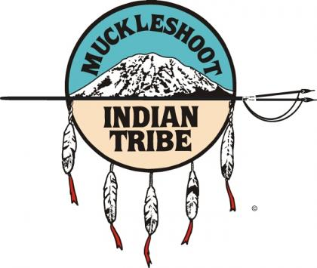 Muckleshoot Indian Tribe
Tribal Services Profile

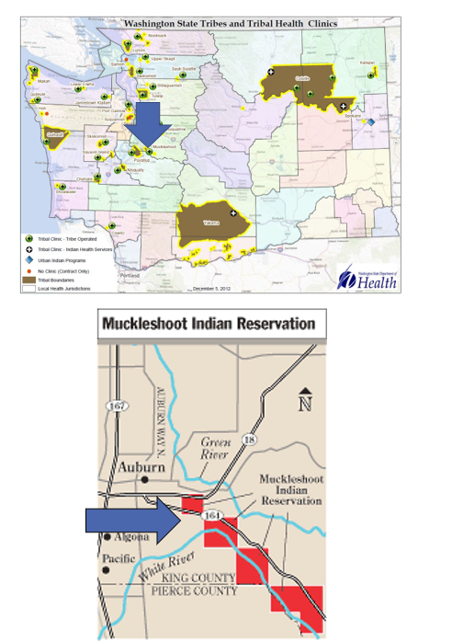

Contents
Reservation (optional) 3
Service Population 3
Medical Services 3
Medical Services List 3
Dental Services 4
Dental Services List 4
Outpatient Mental Health Services 4
Outpatient Mental Health Services List 4
Tribal Crisis Services 5
Tribal Crisis Services 5
Tribal Crisis Coordination Protocol 5
Outpatient Substance Use Disorders Treatment 5
Outpatient SUD Treatment Services List 6
Inpatient Substance Use Disorders Treatment 6
Inpatient SUD Treatment Services List 6
Community Health Services 6
Community Health Services List 6
Social Services (not listed above) 6
Social Services List (not listed above) 7

Reservation (optional)
Land | 3922 acres
Boundaries | King County and Pierce County border the Muckleshoot Reservation; the White River runs through the Reservation
Community Structures | community center, gym, library, longhouse, medical clinic, dental clinic, government administration offices, health administration offices, early childhood education center, behavioral health center, community church, salmon hatchery, water treatment facility, gas station, convenience store, casino, youth center, seniors center
Households | 1,358*
Total Population | 3,959*
Population American Indian and Alaska Native | 1,103*
Population Other Race | 2,856*
*Information from My Tribal Area website: https://www.census.gov/tribal/ U.S. Census Bureau 2019-2023 American Community Survey

Service Population
Total Service Population | 4,929 User Population
Contract Health Services/Purchase and Referred Care Area (Zip Codes) | 98092, 98002, 98022, 98093

Medical Services
Name | Muckleshoot Health & Wellness Center
Address | 17500 SE 392nd St, Auburn, 98092
Phone Number | 253.294.8229
Hours of Operation | Monday-Friday 8am-5pm
After-Hours On-Call | No
Patient Portal | No
Website | http://www.muckleshoot.nsn.us/services/health-and-wellness.aspx (Updates in Process)
Types of Coverage | Call to Verify
Eligibility | Tribal Members Only
Primary Care Clinic (Title V Compact With IHS) (eligibility) | Yes
Primary Care Clinic (IHS Service Unit) (eligibility) | No

Medical Services List
Nephrology
Massage Therapy
Nutrition Education
Obstetrics
ENT
Wound Care
Medication Management
Post-Hospitalization Coordination of Care

Dental Services
Name | Muckleshoot Health & Wellness Center
Address | 17500 SE 392nd St, Auburn, 98092
Phone Number | 253.939.2131
Hours of Operation | Monday-Friday 8am-5pm
After-Hours On-Call | No
Patient Portal | No
Website | http://www.muckleshoot.nsn.us/services/health-and-wellness.aspx (Updates in Process)
Specialty Care | Dentures
Dental Clinic (Title V Compact With IHS) | Yes
Dental Clinic (IHS Service Unit) | No

Dental Services List
Dentures
Early Childhood Dental Caries Prevention
Incentives for Routine Care Completion

Outpatient Mental Health Services
Name | Muckleshoot Behavioral Health Services
Address | 17813 SE 392nd St., Auburn, WA 98092-9705
Phone Number | 253.804.8752 / Afterhours: 253.290.2824
Hours of Operation | Monday-Friday 8am-5pm
To make an appointment or inquire about walk-ins | 253.804.8752
Patient Portal | No
Website | http://www.muckleshoot.nsn.us/services/health-and-wellness.aspx (Updates in Process)
Culturally-Informed Mental Health Programs | Traditional Arts Therapy, Natural Helpers

Outpatient Mental Health Services List
Harm Reduction Services
Individual Counseling
Family Counseling
Facilitated Support Groups
Psychiatric Care/Medication Management
Suicide Prevention
Mind Care Services- Neurofeedback Therapy
Equine Therapy
Youth Residential Services/Supportive Housing
Apothecary Plant Medicine
Anger Management
EMDR
Telehealth Available
Counselor of the Day

Tribal Crisis Services
Name | Muckleshoot Behavioral Health Services
Address | 17813 SE 392nd St., Auburn, WA 98092-9705
Phone Number | 253.290.2824
Hours of Operation | 24/7
To make an appointment or inquire about walk-ins | 253.804.8752 (Monday-Friday 8am-5pm)
Website | http://www.muckleshoot.nsn.us/services/health-and-wellness.aspx (Updates in Process)

Tribal Crisis Services
Service | Contact Name | Phone
Designated Crisis Responder | Crisis Connections | 206.263.9200 / 866.427.4747
Mobile Crisis Response | Crisis Connections | 206.263.9200 / 866.427.4747
24 Hour Tribal Crisis or Call Line | 988 | 988 Option #4
Suicide Prevention Coordinator | Muckleshoot Behavioral Health Services - Afterhours Line | 253.290.2824

Tribal Crisis Coordination Protocol
Is there a Tribal Crisis Coordination Protocol in place?
Yes | No | Link
 | In Progress

Outpatient Substance Use Disorders Treatment
Name | Muckleshoot Behavioral Health Services
Address | 17813 SE 392nd St., Auburn, WA 98092-9705
Phone Number | 253.804.8752
Hours of Operation | Monday-Friday 8am-5pm
After-Hours On-Call | 253.290.2824
Patient Portal | No
Website | http://www.muckleshoot.nsn.us/services/health-and-wellness.aspx (Updates in Process)
Culturally-Informed Programs | Canoe Journey Treatment Linkages, Sweat Lodges

Outpatient SUD Treatment Services List
Individual Counseling
General Outpatient (1.0 loc)
Intensive Outpatient Treatment (2.1 loc)
Inpatient Treatment Assessment Coordination and Referral
DUI Assessments
Group Counseling
Relapse Prevention
Medication Assisted Treatment
Staffed Recovery Housing (Youth and Adult)
Clean and Sober Housing
Apothecary Plant Medicine
Counselor of the Day
Harm Reduction
Detox Referrals
MRT
Seeking Safety
Red Road to Wellbriety
Men and Women Groups
ART (Anger Replacement Therapy)
Equine Therapy
Mindcare
Arts Therapy
Healing Garden
Positive Indian Parenting Groups
Fatherhood and Motherhood are Sacred Curriculum
Fallen Warriors Curriculum
Community Outreach

Detox and Inpatient Substance Use Disorders Treatment
Name | N/A – Coordination for Higher Levels of Care
Address | N/A
Phone Number | N/A
Hours of Operation | N/A
After-Hours On-Call | N/A
Patient Portal | N/A
Website | N/A
Culturally-Informed Programs | N/A

Inpatient SUD Treatment Services List
N/A – Coordination for Higher Levels of Care

Community Health Services
Name | Muckleshoot Health & Wellness Center
Address | 17500 SE 392nd St, Auburn, 98092
Phone Number | 253.294.8201
Hours of Operation | Monday-Friday 8am-5pm
After-Hours On-Call | No
Patient Portal | No
Website | http://www.muckleshoot.nsn.us/services/health-and-wellness.aspx (Updates in Process)

Community Health Services List
WIC
Muckleshoot Pregnancy and Labor Support (Doula)
Medical Transports
Immunizations
Diabetes Management Education
Traditional Foods Nutrition Education
MEIHSS (Muckleshoot Elders in Home Support Services)
Public Health Nursing
Cancer Nurse Navigator
Physical Therapy
Optometry
Community Support Services
Medical Social Worker

Social Services (not listed above)
Name | Muckleshoot Resource Center
Address | 38907 172nd Ave SE, Auburn, WA 98092
Phone Number | (253) 876-3336
Website | https://www.muckleshoot.nsn.us/depts/family-resources

Social Services List (not listed above)
Program Name | Contact Name | Phone & Email
Tribal Assister Program | Luke Moses – Managed Care Lead | Phone: 253.294.8201 Ext. 7321  Email: CHS@muckleshoot-health.com
Youth | Alexandra Cruz-james | Phone: 253.833.8782  Email: MCFSadmin@muckleshoot.nsn.us
Elders | Helen Jameson | Phone: 253.876.2888  Email: helen.jameson@muckleshoot.nsn.us
Cultural | Stephanie James | Phone: 253.876.2994  Email: Stephanie.James@muckleshoot.nsn.us
Veterans | Jesse McDaniel | Phone: 253.876.3297  Email: Jesse.Mcdaniel3@Muckleshoot.nsn.us

