Swinomish Tribe
Tribal Services Profile

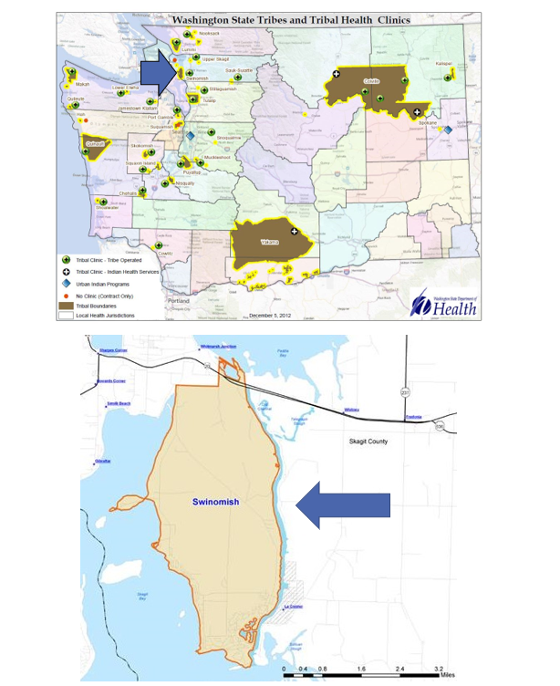

Contents
Reservation (optional) 3
Service Population 3
Medical Services 3
Medical Services List 3
Dental Services 4
Dental Services List 4
Outpatient Mental Health Services 4
Outpatient Mental Health Services List 4
Tribal Crisis Services 5
Tribal Crisis Services 5
Tribal Crisis Coordination Protocol 5
Outpatient Substance Use Disorders Treatment 5
Outpatient SUD Treatment Services List 6
Inpatient Substance Use Disorders Treatment 6
Inpatient SUD Treatment Services List 6
Community Health Services 6
Community Health Services List 6
Social Services (not listed above) 6
Social Services List (not listed above) 7

Reservation (optional)
Land | 7450 acres of upland and 2900 acres of tidelands
Boundaries | Surrounded by 27 miles of saltwater shoreline; on the west is Skagit Bay, on the east is the Swinomish Channel, and on the north is Padilla Bay
Community Structures | - Community center  - Gymnasium  - Youth Center  - Government Administration Building  - Natural Resources Building  - Social Services Building  - Medical Clinic  - Dental Clinic  - Early Childhood Education and Childcare Center  - Behavioral Health Center  - Baseball Field  - Community Churches  - Community Pier  - Fuel Stations  - Convenience Store  - Casino  - Police Building  - Transitional Living  - Domestic Violence Shelter  - Maintenance and Facilities Center  - Housing Building  - Fish and Wildlife Building  - Fitness Building  - Golf Course  - Achieve Building
Households (Same House) | 2,753*
Total Population | 3,148*
Population American Indian and Alaska Native | 520*
Population Other Race | 2,628*
*Information from My Tribal Area website: https://www.census.gov/tribal/ U.S. Census Bureau 2019-2023 American Community Survey

Service Population
Total Service Population | 1450
Contract Health Services/Purchase and Referred Care Area (Zip Codes) | 98257

Medical Services
Name | Swinomish Medical Clinic
Address | 17400 Reservation Rd, La Conner 98257
Phone Number | 360.466.3167
Hours of Operation | Mon-Wed 8Am-6PM Thu 8Am-5:30 PM
After-Hours On-Call | N/A
Patient Portal | N/A
Website | http://www.swinomish.org/resources/health-wellness/medical-clinic.aspx
Types of Coverage | Purchased and Referred Care (PRC)  Primary Care  Specialty Care Services
Eligibility | All enrolled Native Americans from federally recognized tribes
Primary Care Clinic (Title V Compact With IHS) (eligibility) | Yes
Primary Care Clinic (IHS Service Unit) (eligibility) | No

Medical Services List
Pediatrics
Nutrition
Physical Therapy
Wound Care
Medication Management
Chronic Disease Management
Chronic Pain Management

Dental Services
Name | Swinomish Dental
Address | 17395 Reservation Rd, La Conner 98257
Phone Number | 360.466.3900
Hours of Operation | Mon-Wed 8Am-6Pm Thu 8Am-5:30PM
After-Hours On-Call | N/A
Patient Portal | N/A
Website | http://www.swinomish.org/resources/health-wellness/dental.aspx
Specialty Care | Pediatrics, Endodontics
Dental Clinic (Title V Compact With IHS) | Yes
Dental Clinic (IHS Service Unit) | No

Dental Services List
Pediatrics
Endodontics
Dental Health Aides
Early Childhood Dental Caries Prevention

Outpatient Mental Health Services
Name | Swinomish Medical Clinic
Address | 17400 Reservation Rd, La Conner 98257
Phone Number | 360.466.7265
Hours of Operation | Mon-Wed 8Am-6PM Thu 8Am-5:30 PM
To make an appointment or inquire about walk-ins | 360.466.7265
Patient Portal | No
Website | http://www.swinomish.org/resources/health-wellness/swinomish-counseling-services.aspx
Culturally-Informed Mental Health Programs | Natural Helpers

Outpatient Mental Health Services List
Harm Reduction Services
Available to All Ages
Individual Counseling
Family Counseling
Psychiatric Care
Youth Counseling
Youth Mental Health Activities

Tribal Crisis Services
Name | One Number Away
Address | 17400 Reservation Rd, La Conner 98257
Phone Number | 360.466.7375
Hours of Operation | Mon-Thurs 8am-6pm
To make an appointment or inquire about walk-ins | Drop in: Mon & Wed 9am-5pm  Appt: 360.466.3176
Website | https://www.swinomish-nsn.gov/health-and-wellness/page/behavioral-health

Tribal Crisis Services
Service | Contact Name | Phone
Tribal Designated Crisis Responder | N/A
Tribal Mobile Crisis Response | N/A
24 Hour Tribal Crisis or Call Line | Laura Lindberg | 360.466.7375 (not 24 HR, but checked frequently)
Suicide Prevention Coordinator | N/A

Tribal Crisis Coordination Protocol
Is there a Tribal Crisis Coordination Protocol in place?
Yes | No | Link
 | In Progress

Outpatient Substance Use Disorders Treatment
Name | Didgwalic Wellness Center
Address | 8212 S. March Point Road, Anacortes 98221
Phone Number | 360.588.2800
Hours of Operation | Mon 6AM- 12PM Tues-Fri 5:30Am-12Pm
After-Hours On-Call | No
Patient Portal | No
Website | https://swinomish-nsn.gov/resources/health-wellness/wellness-program.aspx
Culturally-Informed Programs | Natural Helpers

Outpatient SUD Treatment Services List
Assessment
Available to All Ages
Individual Counseling
Intensive Outpatient
Group Counseling
Half-Way House Case Management
Needle Exchange Program
Suboxone Program
DUI Deferred Prosecution
Inpatient Referrals
Gambling Awareness, Education, And Counseling
Transitional Living

Inpatient Substance Use Disorders Treatment
Name | N/A
Address | N/A
Phone Number | N/A
Hours of Operation | N/A
After-Hours On-Call | N/A
Patient Portal | N/A
Website | N/A
Culturally-Informed Programs | N/A

Inpatient SUD Treatment Services List
N/A

Community Health Services
Name | Swinomish Wellness Center
Address | 17337 Reservation Road La Conner WA 98257
Phone Number | 360.466.7307
Hours of Operation | Mon- Wed 8AM-6PM  Thur 8AM-5:30PM
After-Hours On-Call | No
Patient Portal | No
Website | https://swinomish.org/resources/social-services.aspx

Community Health Services List
WIC
MSS
Medical Transports
Immunizations
Diabetes Management Education
Traditional Foods Nutrition Education

Social Services List (not listed above)
Program Name | Contact Name | Phone & Email
Tribal Assister Program | N/A | Phone:  Email:
Youth | Angela Ball | Phone: 360.420.3812  Email: ABall@swinomish.nsn.us
Elders | Amanda Buck | Phone: 360.499.4056  Email: Abuck@swinomish.nsn.us
Food Assistance | Michelle Skidmore | Phone: 360.466.7269  Email: MSkidmore@swinomish.nsns.us
Employment / Housing Assistance | Stephanie Edwards | Phone: 360.466.7347  Email: SEdwards@swinomish.nsn.us
Energy Assistance | N/A | Phone: 360.466.7223
Website | https://swinomish.org/resources/social-services.aspx

