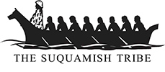 Suquamish Tribe
Tribal Services Profile

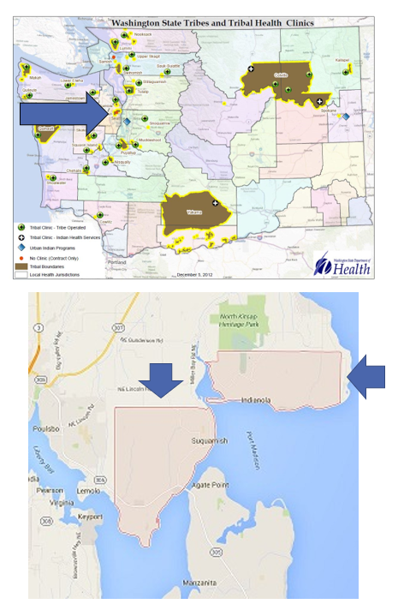

Contents
Reservation (optional) 3
Service Population 3
Medical Services 3
Medical Services List 3
Dental Services 4
Dental Services List 4
Outpatient Mental Health Services 4
Outpatient Mental Health Services List 4
Tribal Crisis Services 5
Tribal Crisis Services 5
Tribal Crisis Coordination Protocol 5
Outpatient Substance Use Disorders Treatment 5
Outpatient SUD Treatment Services List 6
Inpatient Substance Use Disorders Treatment 6
Inpatient SUD Treatment Services List 6
Community Health Services 6
Community Health Services List 6
Social Services (not listed above) 6
Social Services List (not listed above) 7

Reservation (optional)
Land | 7,657 acres, of which 1,475 acres are owned by the Suquamish Tribe, 2,601 acres are owned by individual citizens of the Suquamish Tribe, and 3,581 acres are owned by non-Indians
Boundaries | Miller Bay lies to the east, Kitsap County is to the north, south and west
Community Structures | - community center building  - canoe shed  - fitness center, including indoor and outdoor courts  - youth center  - Elder’s Lodge  - 2 education campuses  - carving shed  - Social Services and Health Administration building  - Wellness Center (behavioral health center)  - baseball field  - salmon hatchery  - casino  - museum  - golf course
Households | 3117* Census 2010
Population Total | 7640* Census 2010
Population Indian | 1143* Census 2010
Population Non-Indian | 6497* Census 2010
*Information from My Tribal Area website: https://www.census.gov/tribal/ U.S. Census Bureau 2019-2023 American Community Survey

Service Population
Total Service Population | Approximately 900
Contract Health Services/Purchase and Referred Care Area (Zip Codes) | 98392

Medical Services
Name | Healing House Primary Care
Address | 6968 Enetai Lane NE, Suquamish WA 98392
Phone Number | 360.394.1350
Hours of Operation | Mon-Fri 8:30am-4:30pm Closed for lunch 12pm-1pm
After-Hours On-Call | No
Patient Portal | Yes
Website | https://suquamish.nsn.us/health-division/healing-house/primary-care/
Types of Coverage | Primary care
Eligibility | Tribal members in Kitsap/All Community members with Medicaid
Primary Care Clinic (Title V Compact With IHS) (eligibility) | Yes
Primary Care Clinic (IHS Service Unit) (eligibility) | Yes
Health Benefits/Tribal Assisters | Phone: 360.394.8424 Email: health_benefits_email@suquamish.nsn.us

Medical Services List
Well-child, teen, and adult annual preventive visits
Minor skin procedures
Family planning counseling, prescriptions and procedures
Pediatric and Prenatal care for low-risk pregnancies
Muscle and joint pain
Chronic diseases such as diabetes, high blood pressure, thyroid disease, high cholesterol
Rare and limited controlled substances (benzodiazepines, opiates, stimulants)
Mental health medication
Medication assisted therapy (MAT)
Follow up after hospitalization
Annual flu vaccination for established patients (see FAQ)
Allergy shot injections (patients must have had Allergist evaluation; Allergist provides serum mixture)
Acupuncture: pain, headaches, menopause, anxiety, sleep, restless legs, nerve pain

Dental Services
Name | N/A – Coordinate with Port Gamble S’klallam Dental Clinic
Address | N/A
Phone Number | N/A
Hours of Operation | N/A
After-Hours On-Call | N/A
Patient Portal | N/A
Website | N/A
Specialty Care | N/A
Dental Clinic (Title V Compact With IHS) | N/A
Dental Clinic (IHS Service Unit) | N/A

Dental Services List
Port Gamble Sklallam Dental Clinic Phone : 360.297.3888
Health Benefits Phone: 360.394.8424 Email: health_benefits_email@suquamish.nsn.us

Outpatient Mental Health Services
Name | Suquamish Tribe Wellness Center
Address | 18490 Suquamish Way NE, Suquamish 98392
Phone Number | 360.394.8558
Hours of Operation | Mon- Fri 8AM-4:30PM
To make an appointment or inquire about walk-ins | 360.394.8558
Patient Portal | No
Website | https://suquamish.nsn.us/home/departments/wellness-center/
Culturally-Informed Mental Health Programs | Traditional Arts Therapy, Healthy and Whole

Outpatient Mental Health Services List
Individual Mental Health Assessments
Child Counseling
Adult Counseling
Family & Relationship Counseling
Medication Management
Mental Health Groups
Victims Services
Problem Gambling Services
Prevention and Outreach Services
Transportation Services

Tribal Crisis Services
Name | N/A Coordinates through Salish Regional Crisis Line
Address | N/A
Phone Number | N/A
Hours of Operation | N/A
To make an appointment or inquire about walk-ins | N/A
Website | N/A

Tribal Crisis Services
Service | Contact Name | Phone
Tribal Designated Crisis Responder | N/A
Tribal Mobile Crisis Response | N/A
24 Hour Tribal Crisis or Call Line | N/A
Suicide Prevention Coordinator | N/A

Tribal Crisis Coordination Protocol
Is there a Tribal Crisis Coordination Protocol in place?
Yes | No | Link
 | In Progress

Outpatient Substance Use Disorders Treatment
Name | Suquamish Tribe Wellness Center
Address | 18490 Suquamish Way NE, Suquamish 98392
Phone Number | 360.394.8558
Hours of Operation | Mon- Fri 8AM-4:30PM
After-Hours On-Call | N/A
Patient Portal | N/A
Website | https://suquamish.nsn.us/home/departments/wellness-center/
Culturally-Informed Programs | Wellbriety and White Bison

Outpatient SUD Treatment Services List
Assessments
Co-Occurring
Apple Health
DUI
Intense Outpatient Programs
Detox Referral & Coordination
Standard Outpatient Programs
Individual SUD Counseling
Drug Court Treatment
Inpatient Referral & Coordination

Inpatient Substance Use Disorders Treatment
Name | N/A
Address | N/A
Phone Number | N/A
Hours of Operation | N/A
After-Hours On-Call | N/A
Patient Portal | N/A
Website | N/A
Culturally-Informed Programs | N/A

Inpatient SUD Treatment Services List
Referrals Only

Community Health Services
Name | Suquamish Tribe Community Health
Address | 18490 Suquamish Way Suquamish, WA 98392
Phone Number | 360.394.8469
Hours of Operation | Mon-Fri 8:30am-4:30pm Closed for lunch 12pm-1pm
After-Hours On-Call | No
Patient Portal | Yes
Website | https://suquamish.nsn.us/health-division/community-health/

Community Health Services List
Care Coordination
Medical Case Management
Nurse Home Visits and Welfare Checks
Patient Advocacy
Medical Transportation
Durable Medical Equipment Assistance, Coordination and Delivery
Nutrition Services
WIC
Support Groups
Educational Classes
Tabacco Cessation Assistance
Medication Management and Pick-Up
Flu Vaccine Clinic
Covid-19 Vaccines and Boosters
Basic Nursing Services and so much more

Social Services (not listed above)
Name | Social Services Program
Address | 18490 Suquamish Way NE Suquamish, WA 98392
Phone Number | 360-394-8650
Website | https://suquamish.nsn.us/home/departments/human-services/social-services/

Social Services List (not listed above)
Program Name | Contact Name | Phone & Email
Tribal Child Welfare | Heather Zaiss | Phone: 360.394.8480  Email: hzaiss@suquamish.nsn.us
477 Yusawiac (Workforce Program) | Brittany Bakken | Phone: 360.394.8544  Email: bbakken@suquamish.nsn.us
Family and Friends Center (Youth) | Barb Santos | Phone: 360.394.8576  Email: bsantos@suquamish.nsn.us
Elders | Della Crowell | Phone: 360.394.8417  Email: dcrowell@suquamish.nsn.us
Cultural Resources Department | Kate Ahvakana | Phone: (360) 394-8573  Email: kahvakana@suquamish.nsn.us
General Assistance and Veterans | Julie Mace | Phone: 360.394.8413  Email: jmace@suquamish.nsn.us

