 Quileute Nation
Tribal Services Profile

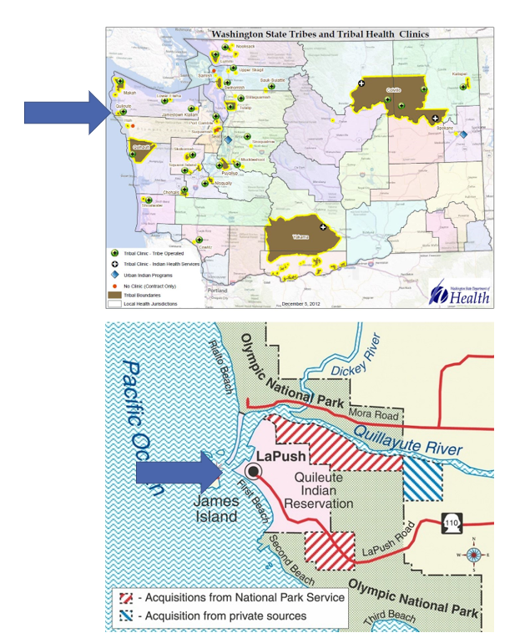

Contents
Reservation (optional) 3
Service Population 3
Medical Services 3
Medical Services List 3
Dental Services 4
Dental Services List 4
Outpatient Mental Health Services 4
Outpatient Mental Health Services List 4
Tribal Crisis Services 5
Tribal Crisis Services 5
Tribal Crisis Coordination Protocol 5
Outpatient Substance Use Disorders Treatment 5
Outpatient SUD Treatment Services List 6
Inpatient Substance Use Disorders Treatment 6
Inpatient SUD Treatment Services List 6
Community Health Services 6
Community Health Services List 6
Social Services (not listed above) 6
Social Services List (not listed above) 7

Reservation (optional)
Land | 1003 acres
Boundaries | Pacific Ocean is west of the reservation. Quillayute River to the North. Olympic National Park to the east and south.
Community Structures | Community center, gym, library, youth center, administration building, tribal school, natural resources building, social services building, medical clinic, dental clinic, health center building, early childhood education and child care center, behavioral health center, baseball field, community church, salmon hatchery, water treatment facility, gas station, convenience store, teen center, marina
Households | 92*
Total Population | 367*
Population American Indian and Alaska Native | 296*
Population Other Race | 71*
*Information from My Tribal Area website: https://www.census.gov/tribal/ U.S. Census Bureau 2019-2023 American Community Survey

Service Population
Total Service Population | 1236
Contract Health Services/Purchase and Referred Care Area (Zip Codes) | 98350

Medical Services
Name | Quileute Health Center
Address | 560 Quileute Heights, La Push, 98350
Phone Number | 360.374.9035 ext. 101
Hours of Operation | Mon-Fri 8am-4pm Closed for lunch 12pm-1pm
After-Hours On-Call | No
Patient Portal | No
Website | https://quileutenation.org/government/health-center/medical-clinic/
Types of Coverage | Primary Care
Eligibility | Members of Federally Recognized Tribes and Descendants & Tribal Employees and their families for select services. Any La Push Community Members (select services)
Primary Care Clinic (Title V Compact With IHS) (eligibility) | Yes
Primary Care Clinic (IHS Service Unit) (eligibility) | No

Medical Services List
Pediatrics, Nutrition, Chiropractic, Acupuncture, Wound Care, Medication Management, Chronic Disease Management, Diabetes Disease Management and Education, WIC, Massage, and Podiatry, Immunizations, Maternity Support Services, Limited Lab and Prescription Services, Vivitrol and Suboxone Services.

Dental Services
Name | Quileute Health Center
Address | 560 Quileute Heights Loop La Push WA 98350
Phone Number | 360.374.9035 ext. 201
Hours of Operation | Mon-Thu 8am-4pm Closed for lunch 12pm-1pm
After-Hours On-Call | No
Patient Portal | No
Website | https://quileutenation.org/clinic/dental-clinic/
Specialty Care | Pediatrics and Adult
Dental Clinic (Title V Compact With IHS) | Yes
Dental Clinic (IHS Service Unit) | No

Dental Services List
Pediatric, early childhood dental caries prevention, incentives for routine care completion

Outpatient Mental Health Services
Name | Quileute Health Center
Address | 560 Quileute Heights Loop PO Box 189 La Push WA 98350
Phone Number | 360.374.9035 ext. 301
Hours of Operation | Tues-Fri 7am-5pm Closed for lunch 12pm-1pm
To make an appointment or inquire about walk-ins | 360.374.9035 ext. 301
Patient Portal | https://qhc-behaviorhealth.clientsecure.me
Website | https://quileutenation.org/clinic/chemical-dependency/
Culturally-Informed Mental Health Programs | Healing Circle & variety of healing modalities

Outpatient Mental Health Services List
Harm Reduction Services
Available to All Ages
Individual Counseling
Family Counseling

Tribal Advocacy Services
Name | New Beginnings / House of Healing
Address | 560 Quileute Heights Loop PO Box 189 La Push WA 98350
Phone Number | 360.374.9035 ext. 110 or 112
Hours of Operation | Mon-Fri 8am-4pm Closed for lunch 12pm-1pm
Website | https://quileutenation.org/government/health-center/behavioural-health/new-beginnings/

Tribal Advocacy Services
Service | Contact Name | Phone
Domestic Violence Advocate | Vacant | 360.374.9035 ext. 112
Survivors Support Advocate | Vacant | 360.374.9035 ext. 110
Cultural Advocate | Randy Eastman Jr. | 360.640.5053

Tribal Crisis Coordination Protocol
Is there a Tribal Crisis Coordination Protocol in place?
Yes | No | Link
 | In Progress

Outpatient Substance Use Disorders Treatment
Name | Quileute Counseling and Recovery Services
Address | 579 Hermison Road Forks, WA 98331
Phone Number | 360.374.9035 ext. 301
Hours of Operation | Mon-Fri 8am-4pm Closed for lunch 12pm-1pm
After-Hours On-Call | No
Patient Portal | https://qhc-behaviorhealth.clientsecure.me
Website | https://quileutenation.org/clinic/chemical-dependency/
Culturally-Informed Programs | Healing Circle & variety of healing modalities

Outpatient SUD Treatment Services List
Available to All Ages
Individual Counseling
Group Counseling

Community Health Services
Name | Quileute Health Center
Address | 560 Quileute Heights Loop PO Box 189 La Push WA 98350
Phone Number | 360.374.9035 Community Health Representative ext. 104 Community Health Worker ext. 113
Hours of Operation | Mon-Fri 8am-4pm Closed for lunch 12pm-1pm
After-Hours On-Call | No
Patient Portal | No
Website | https://quileutenation.org/human-services/

Community Health Services List
Medical Transports
Youth Service Outreach Support (Birth-18 y/o)
Prescription Pick-up
Referral Management
Tribal Assister

Social Services (not listed above)
Name | Quileute Human Services
Address | 191 Ocean Drive La Push, WA 98350
Phone Number | 360.374.4306
Website | https://quileutenation.org/government/human-services/staff-and-services/

Social Services List (not listed above)
Program Name | Contact Name | Phone & Email
LIHEAP | Stephanie Calderon | Phone: 360.374.4271  Email: stephanie.calderon@quileutetribe.com
TANF | Michele Pullen | Phone: 360.374.5185  Email: michele.pullen@quileutetribe.com
Elders | Clifford Hoekstra | Phone: 360.374.6040  Email: clifford.hoekstra@quileutetribe.com
Food Program/Food Pantry/ FDPIR | Anna Sablan | Phone: 360.374.2147  Email: anna.sablan@quileutetribe.com
Employment | Stephanie Calderon | Phone: 360.374.4271  Email: stephanie.calderon@quileutetribe.com
Prevention | Ann Penn-Charles | Phone: 360.374.2228  Email: ann.penn-charles@quileutetribe.com
Kinship | Dawn Reid | Phone: 360.374.3353  Email: kinship.navigator@quileutetribe.com
Health Home | Clifford Hoekstra | Phone: 360.374.6040  Email: clifford.hoekstra@quileutetribe.com
Youth | Michele Pullen | Phone: 360.374.5185  Email: michele.pullen@quileutetribe.com

