 Spokane Tribe of Indians
Tribal Services Profile

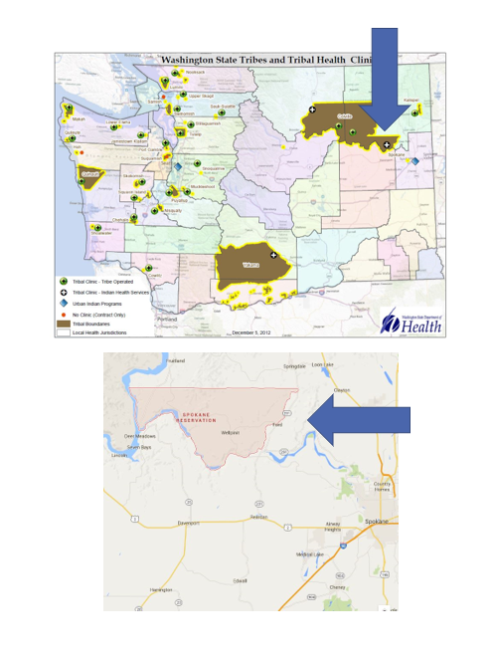

Contents
Reservation (optional) 3
Service Population 3
Medical Services 3
Medical Services List 3
Dental Services 4
Dental Services List 4
Outpatient Mental Health Services 4
Outpatient Mental Health Services List 4
Tribal Crisis Services 5
Tribal Crisis Services 5
Tribal Crisis Coordination Protocol 5
Outpatient Substance Use Disorders Treatment 5
Outpatient SUD Treatment Services List 6
Inpatient Substance Use Disorders Treatment 6
Inpatient SUD Treatment Services List 6
Community Health Services 6
Community Health Services List 6
Social Services (not listed above) 6
Social Services List (not listed above) 7

Reservation (optional)
Land | 159,000 acres
Boundaries | The Spokane Tribe of Indians reservation boundaries are defined by the East Bank of Tshimakain Creek, the South Bank of the Spokane River, the West Bank of the Columbia River, and the Northern Border is the 48th parallel. The reservation is located in a remote portion of northeast Washington State and encompasses approximately 159,000 acres.
Community Structures | - Administrative building  - Community center (Westend)  - Boys & Girls Club  - Gym  - Library  - Longhouse  - Youth center (Ford)  - Education center  - Natural resources building  - Social services building  - Medical clinic  - Dental clinic  - Health administration building  - Early childhood education  - Child care center  - Behavioral health center  - Senior Center  - Community church X 4  - Fish hatchery  - Community pier  - Water treatment facility  - Gas station X 2  - Convenience store  - Pavilion-water front camping area
Households | 725*
Total Population | 1,884*
Population American Indian and Alaska Native | 1,290*
Population Other Race | 594*
*Information from My Tribal Area website: https://www.census.gov/tribal/ U.S. Census Bureau 2019-2023 American Community Survey

Service Population
Total Service Population | N/A
Contract Health Services/Purchase and Referred Care Area (Zip Codes) | N/A

Medical Services
Name | Spokane Tribal Health
Address | 6203 Agency Loop Road, Wellpinit 99040
Phone Number | 509.606.2018
Hours of Operation | Mon Tue, Thur Fri  8:00 AM - 4:30 PM  Thursday  12:30 AM - 4:30 PM
After-Hours On-Call | No
Patient Portal | No
Website | https://www.ihs.gov/portland/healthcarefacilities/wellpinit/
Types of Coverage | Call for Coverage Specifics
Eligibility | Enrolled Members of Federally Recognized Tribes
Primary Care Clinic (Title V Compact With IHS) (eligibility) | No
Primary Care Clinic (IHS Service Unit) (eligibility) | Yes

Medical Services List
Pediatrics
Nutrition
Wound Care
Medication Management
Chronic Disease Management

Dental Services
Name | Spokane Tribal Health
Address | 6203 Agency Loop Road, Wellpinit 99040
Phone Number | 509.258.4517
Hours of Operation | Mon Tue Thu Fri 8:00 AM - 4:30 PM Thu  12:30 AM - 4:30 PM
After-Hours On-Call | N/A
Patient Portal | N/A
Website | https://www.ihs.gov/portland/healthcarefacilities/wellpinit/
Specialty Care | N/A
Dental Clinic (Title V Compact With IHS) | No
Dental Clinic (IHS Service Unit) | Yes

Dental Services List
Pediatric Referrals
Oral Surgery Referrals

Outpatient Mental Health Services
Name | Health and Human Services
Address | 6228 E. Old School Rd., Wellpinit, 99040
Phone Number | 509.606.2764
Hours of Operation | Mon- Fri 8:00 AM-4:30 PM
To make an appointment or inquire about walk-ins | (referral form) Case Manager will contact forms can be filled out by agencies  - Call to make a appointment  - Fill out referral form on website  - Can fill out over phone
Patient Portal | N/A
Website | https://www.spokanetribe.com/government/health-and-human-services/
Culturally-Informed Mental Health Programs | Wellbriety  Trauma Informed Community Approach  Healing the effects of Intergenerational Trauma

Outpatient Mental Health Services List
Harm Reduction Services
Individual Treatment
Less Restrictive Alternative (LRA) Support
Recovery Employment Support
Family counseling
Group Counseling
Psychiatric Medication Prescribing/Monitoring
Transportation
Case Management
Brief Intervention Treatment
Crisis Outreach
Crisis Telephone Support – during business hours 8:00 AM-4:30PM 509.606.2764
Psychological Evaluations

Tribal Crisis Services
Name | Spokane Tribe Behavioral Health
Address | 6228 E. Old School Rd., Wellpinit, 99040
Phone Number | 509.606.2764
Hours of Operation | 8:00 A.M - 4:30 PM -After hours call 911
To make an appointment or inquire about walk-ins | Call main line to connect with Mental Health provider
Website | https://www.spokanetribe.com/government/health-and-human-services/

Tribal Crisis Services
Service | Contact Name | Phone
Tribal Designated Crisis Responder | N/A
Tribal Mobile Crisis Response | N/A
24 Hour Tribal Crisis or Call Line | N/A
Suicide Prevention Coordinator | Rachel Ferguson | 509.606.2018

Tribal Crisis Coordination Protocol
Is there a Tribal Crisis Coordination Protocol in place?
Yes | No | Link
 | In Progress

Outpatient Substance Use Disorders Treatment
Name | Health and Human Services
Address | 6228 E. Old School Rd. PO Box 540 Wellpinit, WA 99040
Phone Number | 509.606.2764
Hours of Operation | Mon- Fri 8:00 AM-4:30 PM
After-Hours On-Call | Call 911, 988 or Tribal Dispatch 509.818.1410
Patient Portal | N/A
Website | https://www.spokanetribe.com/government/health-and-human-services/
Culturally-Informed Programs | Wellbriety  Trauma Informed Community Approach  Healing the effects of Intergenerational Trauma

Outpatient SUD Treatment Services List
Level 1.0 Outpatient Services
DUI Assessment
Transportation
Individual counseling
Family counseling
Group counseling
Physician assisted MAT treatment (Outpatient)
Wellbriety Groups
Peer Counselors
Narcan distribution site

Inpatient Substance Use Disorders Treatment
Name | N/A
Address | N/A
Phone Number | N/A
Hours of Operation | N/A
After-Hours On-Call | N/A
Patient Portal | N/A
Website | N/A
Culturally-Informed Programs | N/A

Inpatient SUD Treatment Services List
N/A

Community Health Services
Name | Spokane Tribal Health
Address | 6203 Agency Loop Road, Wellpinit 99040
Phone Number | 509.606.2764
Hours of Operation | Mon - Fri 8:00 AM - 4:30 PM
After-Hours On-Call | Call 911, 988 or Tribal Dispatch 509.818.1410
Patient Portal | N/A
Website | https://www.ihs.gov/portland/healthcarefacilities/wellpinit/

Community Health Services List
Case Management for diabetes
Wellness events
Exercise programs

Social Services (not listed above)
Name | Employment Assistance (Voc Rehab)
Address | N/A
Phone Number | 509. 458.6569
Website | https://www.spokanetribe.com/government/health-and-human-services/vocational-rehabilitation/

Social Services (not listed above)
Name | Housing Assistance
Address | N/A
Phone Number | 509.458.6550
Website | https://spokaneiha.com/

Social Services (not listed above)
Name | Energy Assistance
Address | N/A
Phone Number | 509. 458.6543
Website | https://www.spokanetribe.com/emergency-rental-utility-assistance/

Social Services List (not listed above)
Program Name | Contact Name | Phone & Email
Tribal Assister Program | Lauren Carson | Phone: 509.606.2764  Email:
Youth | N/A | Phone: 509.818.1426  Email:
Elders | N/A | Phone: 509.258.7129  Email: angiec@spokanetribe.com
Cultural | Marsha Wynecoop | Phone: 509.258.4222  Email: marshaw@spokanetribe.com
Veterans | Cheryl Covington | Phone: 509.258.7331  Email: Cheryl.covington@spokanetribe.com

