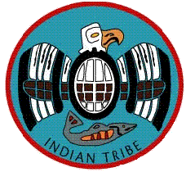 Hoh Indian Tribe
Tribal Services Profile

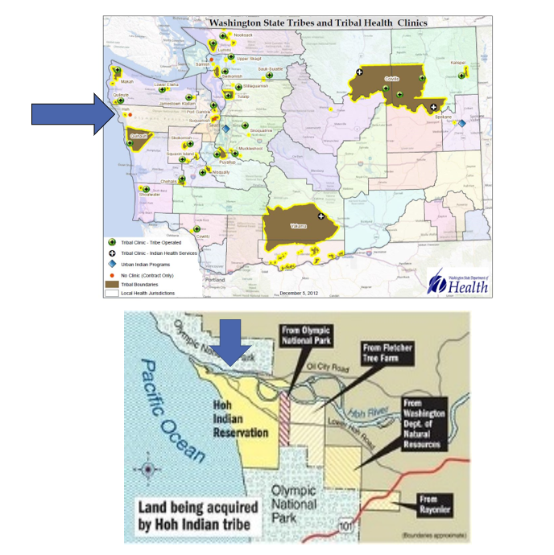

Reservation (optional)
Land | 477 acres
Boundaries | The Hoh River is to the north, the Pacific Ocean is west, Jefferson County is to the east and south
Community Structures | Community center, gym, library, longhouse, youth center, administration building, education center, natural resources building, social services building, early childhood education and childcare center, behavioral health center, baseball field, community church, salmon hatchery, community pier, water treatment facility, gas station, convenience store
Households | 15*
Total Population | 37*
Population American Indian and Alaska Native | 21*
Population Other Race | 16*
*Information from My Tribal Area website: https://www.census.gov/tribal/ U.S. Census Bureau 2019-2023 American Community Survey

Service Population
Total Service Population | To Be Determined
Contract Health Services/Purchase and Referred Care Area (Zip Codes) | 98331

Medical Services
Name | Chief Klia Wellness Center
Address | 2263 Lower Hoh Rd, Forks, WA 98331
Phone Number | 360.374.6582
Hours of Operation | Mon-Fri 8:00am-4:00pm
After-Hours On-Call | No
Patient Portal | No
Website | https://hohtribe-nsn.org/government/health-services/
Types of Coverage | Medical, dental, mental health-offered by outside agencies
Eligibility | Live in-service area (Reservation/Forks area), fill out annual application with IHS
Primary Care Clinic (Title V Compact With IHS) (eligibility) | No
Primary Care Clinic (IHS Service Unit) (eligibility) | No

Medical Services List
Enrolled Tribal Members Only Services:
Diabetic foot care
Acupuncture
Therapeutic Massage

Dental Services
Name | Chief Klia Wellness Center - Coordinated Care Only (none offered on-site)
Address | 2263 Lower Hoh Rd, Forks, WA 98331
Phone Number | 360.374.6582
Hours of Operation | Mon-Fri 8:00am-4:00pm
After-Hours On-Call | N/A
Patient Portal | No
Website | https://hohtribe-nsn.org/government/health-services/
Specialty Care | N/A
Dental Clinic (Title V Compact With IHS) | N/A
Dental Clinic (IHS Service Unit) | N/A

Dental Services List
N/A

Outpatient Mental Health Services – Coordinated Care Available
Name | Chief Klia Wellness Center
Address | 2263 Lower Hoh Rd, Forks, WA 98331
Phone Number | 360.374.6582
Hours of Operation | Mon-Fri 8:00am-4:00pm (After hours 360.780.0399)
To make an appointment or inquire about walk-ins | Call main line or 360.780.0399
Patient Portal | No
Website | https://hohtribe-nsn.org/government/health-services/
Culturally-Informed Mental Health Programs | N/A

Outpatient Mental Health Services List
Harm Reduction Services
Harm Reduction Supply Distribution
Coordinate Virtual Options of care (limited availability)

Regional Crisis Services
Name | Salish Regional Crisis Line
Address | N/A
Phone Number | 888.910.0416
Hours of Operation | 24/7
To make an appointment or inquire about walk-ins | N/A
Website | https://www.kitsapmentalhealth.org/yatt-resource/salish-regional-crisis-line/

Tribal Crisis Services
Service | Contact Name | Phone
Tribal Designated Crisis Responder | N/A
Tribal Mobile Crisis Response | N/A
24 Hour Tribal Crisis or Call Line | N/A
Suicide Prevention Coordinator | N/A

Tribal Crisis Coordination Protocol
Is there a Tribal Crisis Coordination Protocol in place?
Yes | No | Link
 | In Progress

Outpatient Substance Use Disorders Treatment
Name | Chief Klia Wellness Center
Address | 2263 Lower Hoh Rd, Forks, WA 98331
Phone Number | 360.374.6582
Hours of Operation | Mon-Fri 8:00am-4:00pm
After-Hours On-Call | (After hours 360.780.0399)
Patient Portal | No
Website | https://hohtribe-nsn.org/government/health-services/
Culturally-Informed Programs | N/A

Outpatient SUD Treatment Services List
Dispensing Site for Narcan
Dispensing sites in the community for Narcan

Inpatient Substance Use Disorders Treatment
Name | Chief Klia Wellness Center
Address | 2263 Lower Hoh Rd, Forks, WA 98331
Phone Number | 360.374.6582
Hours of Operation | Mon-Fri 8:00am-4:00pm
After-Hours On-Call | After hours 360.780.0399
Patient Portal | No
Website | https://hohtribe-nsn.org/government/health-services/
Culturally-Informed Programs | Referred to outside treatment facilities

Inpatient SUD Treatment Services List
Access to funding for Inpatient SUD Treatment

Community Health Services
Name | Chief Klia Wellness Center
Address | 2263 Lower Hoh Rd, Forks, WA 98331
Phone Number | 360.374.6582
Hours of Operation | Mon-Fri 8:00am-4:00pm
After-Hours On-Call | After hours 360.780.0399
Patient Portal | No
Website | https://hohtribe-nsn.org/government/health-services/

Community Health Services List
Massage, Acupuncture, and foot care offered onsite.

Referrals or coordination of care to other outside agencies as needed.

Social Services (not listed above)
Name | Britni Duncan
Address | 2263 Lower Hoh Rd, Forks, WA 98331
Phone Number | 360.780.0399
E-mail | britni.duncan@hohtribe-nsn.org

Social Services List (not listed above)
Program Name | Contact Name | Phone & Email
DSHS Support | LaToya Hudson | Phone: 360.374.6582  Email: latoya.hudson@hohtribe-nsn.org
Youth – Afterschool program at Library | Britni Duncan | Phone: 360.780.0399  Email: britni.duncan@hohtribe-nsn.org
Elders  O3A – Medicare insurance, in-home care, insurance coverage coordination | LaToya Hudson | Phone: 360.374.6582  Email: : latoya.hudson@hohtribe-nsn.org
Cultural – Monthly Classes at Library for all ages | Britni Duncan | Phone: 360.780.0399  Email: britni.duncan@hohtribe-nsn.org
Veterans – Referrals available | N/A | Phone:  Email:

