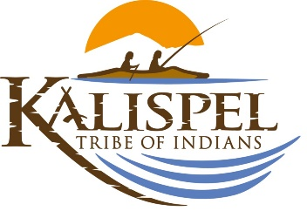 Kalispel Tribe
Tribal Services Profile

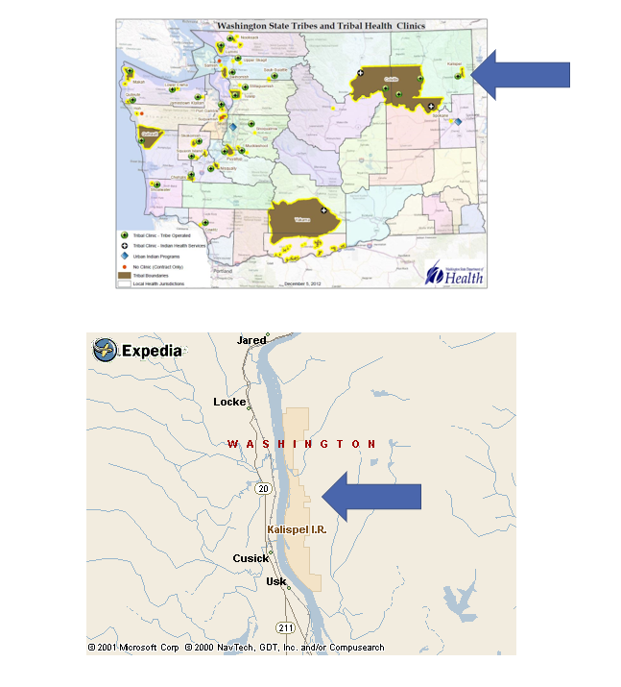

Contents
Reservation (optional) 3
Service Population 3
Medical Services 3
Medical Services List 3
Dental Services 4
Dental Services List 4
Outpatient Mental Health Services 4
Outpatient Mental Health Services List 4
Tribal Crisis Services 5
Tribal Crisis Services 5
Tribal Crisis Coordination Protocol 5
Outpatient Substance Use Disorders Treatment 5
Outpatient SUD Treatment Services List 6
Inpatient Substance Use Disorders Treatment 6
Inpatient SUD Treatment Services List 6
Community Health Services 6
Community Health Services List 6
Social Services (not listed above) 6
Social Services List (not listed above) 7

Reservation (optional)
Land | 252 acres of trust land and 40 acres of trust land in Airway Heights
Boundaries | community center, gym, library, youth center, administration building, education center, natural resources building, social services building, medical clinic, dental clinic, health administration building, early childhood education and child care center, behavioral health center, baseball field, community church, salmon water treatment facility, gas station, convenience store, casino, hotel, elder center, transitional housing, commercial laundry facility, restaurant, fish hatchery, language/cultural resources building, rest stop, public safety building, vocational training building, tribal court, auto repair, public bus barn
Community Structures | 58* Census 2010
Households | 284*
Total Population | 763*
Population American Indian and Alaska Native | 143*
Population Other Race | 620*
*Information from My Tribal Area website: https://www.census.gov/tribal/ U.S. Census Bureau 2019-2023 American Community Survey

Service Population
Total Service Population | 2161
Contract Health Services/Purchase and Referred Care Area (Zip Codes) | 99119

Medical Services
Name | Camas Center Medical & Dental Clinic
Address | 1821 LeClerc Rd N., Cusick, WA 99119
Phone Number | 509.447.7111
Hours of Operation | Monday – Thursday 8am-5pm
After-Hours On-Call | Yes
Patient Portal | Yes
Website | www.kalispeltribe.com
Types of Coverage | Call for Coverage Specifics
Eligibility | Indian and Non-Indian Residents
Primary Care Clinic (Title V Compact With IHS) (eligibility) | Yes
Primary Care Clinic (IHS Service Unit) (eligibility) | No

Medical Services List
Physical Therapy
Pediatrics
Nutrition
OB/Gyn
Wound Care
Medication Management
Home Environment Screenings (for Asthma, Fall Prevention, etc.)
Post-Hospitalization Coordination of Care
Psychiatric Medication Management

Dental Services
Name | Camas Center Medical & Dental Clinic
Address | 1821 LeClerc Rd N., Cusick, WA 99119
Phone Number | 509.447.7111
Hours of Operation | Monday – Thursday 8am-5pm
After-Hours On-Call | Yes
Patient Portal | Yes
Website | www.kalispeltribe.com
Specialty Care | Pediatrics, Endodontics
Dental Clinic (Title V Compact With IHS) | Yes
Dental Clinic (IHS Service Unit) | No

Dental Services List
Early Childhood Dental Caries Prevention
Incentives for Routine Care Completion

Outpatient Mental Health Services
Name | Camas Path
Address | South office: 934 S. Garfield, Airway Heights, WA 99001  North office: 1821 LeClerc Rd N. Cusick, WA 99119
Phone Number | 509.789.7630
Hours of Operation | Monday – Thursday 7am-5pm
To make an appointment or inquire about walk-ins | 509.789.7630
Patient Portal | Yes
Website | www.kalispeltribe.com
Culturally-Informed Mental Health Programs | Traditional Arts Therapy, Natural Helpers

Outpatient Mental Health Services List
Harm Reduction Services
Individual Counseling
Family Counseling
Facilitated Support Groups
Suicide Prevention
Re-Entry Program

Tribal Crisis Services
Name | N/A – Coordination for Higher Levels of Care
Address | N/A
Phone Number | N/A
Hours of Operation | N/A
To make an appointment or inquire about walk-ins | N/A
Website | N/A

Tribal Crisis Services
Service | Contact Name | Phone
Designated Crisis Responder | 1. Pend Oreille County Counseling  2. Spokane County Regional Behavioral Health Crisis Line | 1. 509.447.5651  2. 1.877.266.1818
Tribal Mobile Crisis Response | N/A
24 Hour Tribal Crisis or Call Line | Behavioral Health Advice Line | 509.789.7630
Suicide Prevention Coordinator | N/A

Tribal Crisis Coordination Protocol
Is there a Tribal Crisis Coordination Protocol in place?
Yes | No | Link
 | In Progress

Outpatient Substance Use Disorders Treatment
Name | Camas Path
Address | South office: 934 S. Garfield, Airway Heights, WA 99001  North office: 808 Community Hall Rd. Cusick, WA 99119
Phone Number | 509.789.7630
Hours of Operation | Monday – Thursday 7am-5pm
After-Hours On-Call | Yes
Patient Portal | Yes
Website | www.kalispeltribe.com
Culturally-Informed Programs | Yes

Outpatient Substance Use Disorders Treatment – Medication for Opioid Use Disorder (MOUD)
Name | Camas Health Recovery Center
Address | 10811 W 6th Ave. Airway Heights, WA 99001
Phone Number | (509) 481-4990
Hours of Operation | Monday-Friday 8am-5pm
After-Hours On-Call | No
Patient Portal | No
Website | https://pentagon-wombat-e8nd.squarespace.com/services
Culturally-Informed Programs | N/A

Outpatient SUD Treatment Services List
Individual Counseling
Intensive Outpatient Treatment
Inpatient Treatment
Group Counseling
Relapse Prevention
Detox Medication Assisted Treatment

Inpatient Substance Use Disorders Treatment
Name | N/A
Address | N/A
Phone Number | N/A
Hours of Operation | N/A
After-Hours On-Call | N/A
Patient Portal | N/A
Website | N/A
Culturally-Informed Programs | N/A

Inpatient SUD Treatment Services List
N/A

Community Health Services
Name | Camas Center Medical & Dental Clinic
Address | 1821 LeClerc Rd N., Cusick, WA 99119
Phone Number | 509.447.7111
Hours of Operation | Monday – Thursday 8am-5pm
After-Hours On-Call | Yes
Patient Portal | Yes
Website | www.kalispeltribe.com

Community Health Services
Name | People’s Place – Transitional Living Program
Address | 934 S Garfield Rd Airway Heights, Washington 99001
Phone Number | 509.789.7630
Hours of Operation | 24/7
After-Hours On-Call | No
Patient Portal | No
Website | https://camaspath.org/behavioral-health/peoples-place

Community Health Services List
WIC
MSS
Medical Transports
Immunizations
Diabetes Management Education
Traditional Foods Nutrition Education

Social Services (not listed above)
Name | Kelly Good
Address | 934 S. Garfield, Airway Heights, WA 99001
Phone Number | 509.789.7632
Website | https://camaspath.org/children-family-services/

Social Services List (not listed above)
Program Name | Contact Name | Phone & Email
Tribal Assister Program | Deb Flett | Phone: 509.447.7111  Email:
Youth | Katy Waid | Phone: 509.789.7654  Email:
Elders | Meals, Transportation and Cultural Activities | Phone: 509.447.7111  Email:
Cultural | Language / Traditional Arts & Crafts, Song & Dance Classes | Phone:  509.447.7286 / 509.447.7281  Email:

