 Samish Indian Nation
Tribal Services Profile
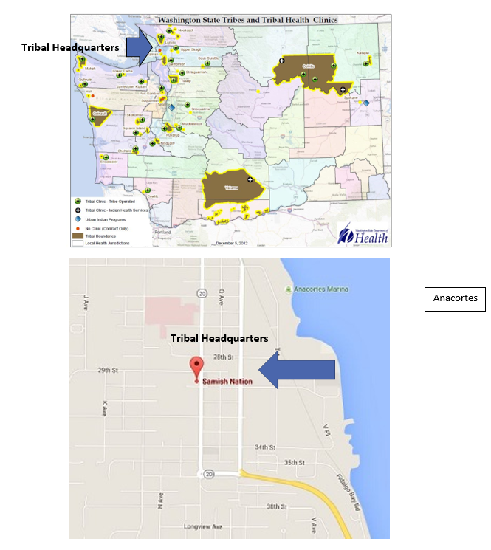

Contents
Reservation (optional) 3
Service Population 3
Medical Services 3
Medical Services List 3
Dental Services 4
Dental Services List 4
Outpatient Mental Health Services 4
Outpatient Mental Health Services List 4
Tribal Crisis Services 5
Tribal Crisis Services 5
Tribal Crisis Coordination Protocol 5
Outpatient Substance Use Disorders Treatment 5
Outpatient SUD Treatment Services List 6
Inpatient Substance Use Disorders Treatment 6
Inpatient SUD Treatment Services List 6
Community Health Services 6
Community Health Services List 6
Social Services (not listed above) 6
Social Services List (not listed above) 7

Reservation (optional)
Land | 79 Acres
Boundaries | The Samish Nation's service delivery area includes Whatcom, Skagit, San Juan, Island, Snohomish, King, Pierce, Kitsap, Jefferson, and Clallam counties.
Community Structures | - government administration offices  - health administration offices  - early childhood education center  - seniors center  - cultural gathering building  - Fidalgo Bay Resort (RV and cottage resort)
Households | No housing offered on reservation. Samish Xwch'angteng Housing (senior housing) is Located in Anacortes, WA.
Population Total | 1200
Population Indian | Tribal members: 2400
Population Non-Indian | N/A

Service Population
Total Service Population | Over 2,000
Contract Health Services/Purchase and Referred Care Area (Zip Codes) | 98221

Medical Services
Name | N/A – Coming in the Future
Address | N/A
Phone Number | N/A
Hours of Operation | N/A
After-Hours On-Call | N/A
Patient Portal | N/A
Website | N/A
Types of Coverage | N/A
Eligibility | N/A
Primary Care Clinic (Title V Compact With IHS) (eligibility) | N/A
Primary Care Clinic (IHS Service Unit) (eligibility) | N/A

Medical Services List
Purchased and Referred Care (PRC) – Andrea Fifield 360.726.3523 afifield@samishtribe.nsn.us

Dental Services
Name | N/A – Coming in the Future
Address | N/A
Phone Number | N/A
Hours of Operation | N/A
After-Hours On-Call | N/A
Patient Portal | N/A
Website | N/A
Specialty Care | N/A
Dental Clinic (Title V Compact With IHS) | N/A
Dental Clinic (IHS Service Unit) | N/A

Dental Services List
Purchased and Referred Care (PRC) – Andrea Fifield 360.726.3523 afifield@samishtribe.nsn.us

Outpatient Mental Health Services
Name | N/A – Coming in Future
Address | N/A
Phone Number | N/A
Hours of Operation | N/A
To make an appointment or inquire about walk-ins | N/A
Patient Portal | N/A
Website | N/A
Culturally-Informed Mental Health Programs | N/A

Outpatient Mental Health Services List
Purchased and Referred Care (PRC) – Andrea Fifield 360.726.3523 afifield@samishtribe.nsn.us

Tribal Crisis Services
Name | Outreach Team Specialist– John Scott
Address | Outreach
Phone Number | Work: 360.726.3907 Cell: 360.821.5461
Hours of Operation | Monday-Friday 8:30am-5pm  Afterhours on Case-by-Case Basis
To make an appointment or inquire about walk-ins | 360.726.3907
Website | No

Tribal Crisis Services
Service | Contact Name | Phone
Tribal Designated Crisis Responder | N/A
Tribal Mobile Crisis Response | John Scott | Work: 360.726.3907 Cell: 360.821.5461
24 Hour Tribal Crisis or Call Line | N/A
Suicide Prevention Coordinator | N/A

Tribal Crisis Coordination Protocol
Is there a Tribal Crisis Coordination Protocol in place?
Yes | No | Link
 | In Progress

Outpatient Substance Use Disorders Treatment – Coordination and Referrals Only
Name | Prevention and Intervention Specialist: Budda Luna
Address | N/A
Phone Number/Email | 360.726.3466 / lluna@samishtribe.nsn.us
Hours of Operation | Monday-Friday 8:30am-5pm
After-Hours On-Call | No
Patient Portal | No
Website | https://www.samishtribe.nsn.us/departments/health/prevention-and-intervention
Culturally-Informed Programs | N/A

Outpatient SUD Treatment Services List
N/A

Inpatient Substance Use Disorders Treatment - Coordination and Referrals Only
Name | Prevention and Intervention Specialist: Budda Luna
Address | N/A
Phone Number | 360.726.3466 / lluna@samishtribe.nsn.us
Hours of Operation | Monday-Friday 8:30am-5pm
After-Hours On-Call | No
Patient Portal | No
Website | https://www.samishtribe.nsn.us/departments/health/prevention-and-intervention
Culturally-Informed Programs | N/A

Inpatient SUD Treatment Services List
N/A

Community Health Services
Name | N/A
Address | N/A
Phone Number | N/A
Hours of Operation | N/A
After-Hours On-Call | N/A
Patient Portal | N/A
Website | N/A

Community Health Services List
Diabetes Management Education - https://www.samishtribe.nsn.us/departments/health/tribal-wellness-services
Purchased and Referred Care (PRC)
About: https://www.samishtribe.nsn.us/departments/health/purchased-and-referred-care
Link to Form: https://secure.samishtribe.nsn.us/Forms/PO-Request-Form

Social Services (not listed above)
Name | Letitia Julian
Email Address | ljulian@samishtribe.nsn.us
Phone Number | 360.298.0104
Website | https://www.samishtribe.nsn.us/departments/social-services

Social Services List (not listed above)
Program Name | Contact Name | Phone & Email
Tribal Assister Program | Andrea Andrea Fifield  Erin Clark | Phone:  Andrea: 360.726.3523  Erin: 360.726.3493  Email: afifield@samishtribe.nsn.us  eclark@samishtribe.nsn.us
Youth | Budda Luna | Phone: 360.726.3466  Email: lluna@samishtribe.nsn.us
Elders | Allison Coonc | Phone: 360.726.3857  Email: acoonc@samishtribe.nsn.us
Cultural | Patricia Breckinridge | Phone: 360.298.1531  Email: pbreckenridge@samishtribe.nsn.us
Veterans | Allison Coonc | Phone: 360.726.3857  Email: acoonc@samishtribe.nsn.us

