 Tulalip Tribes
Tribal Services Profile

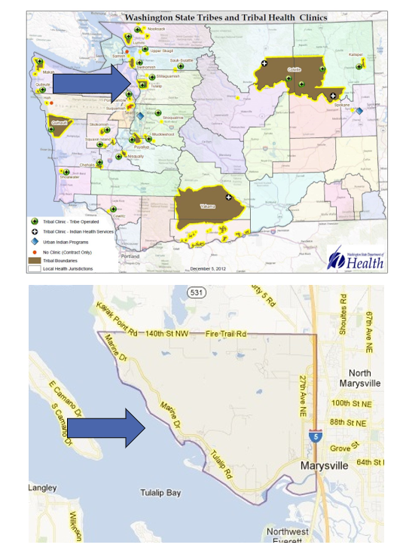

Contents
Reservation (optional) 3
Service Population 3
Medical Services 3
Medical Services List 3
Dental Services 4
Dental Services List 4
Outpatient Mental Health Services 4
Outpatient Mental Health Services List 4
Tribal Crisis Services 5
Tribal Crisis Services 5
Tribal Crisis Coordination Protocol 5
Outpatient Substance Use Disorders Treatment 5
Outpatient SUD Treatment Services List 6
Inpatient Substance Use Disorders Treatment 6
Inpatient SUD Treatment Services List 6
Community Health Services 6
Community Health Services List 6
Social Services (not listed above) 6
Social Services List (not listed above) 7

Reservation (optional)
Land | 22,000 acres
Boundaries | I-5 and Marysville are to the east, the Snohomish River is to the west, Fire Trail Road is north, and Puget Sound is to the west
Community Structures | - Community center  - Gym  - Library  - Longhouse  - Youth Center  - Administration building  - Education Center  - Natural resources building  - Social Services building  - Medical Clinic  - Dental Clinic  - Health administration building  - Early Childhood Education and childcare Center  - Behavioral Health Center  - Baseball field  - Community church  - Salmon hatchery  - Community pier  - Water treatment facility  - Gas station  - Convenience store  - Casino  - Quil Ceda Village Shopping Center
Households (Same House) | 9,213*
Total Population | 10,190*
Population American Indian and Alaska Native | 1,826*
Population Other Race | 8,364*
*Information from My Tribal Area website: https://www.census.gov/tribal/ U.S. Census Bureau 2019-2023 American Community Survey

Service Population
Total Service Population | 6000
Contract Health Services/Purchase and Referred Care Area (Zip Codes) | The primary zip code for Tulalip is 98271. Additionally, the Tulalip Tribes' 477 Program provides services in the following zip codes: 98270, 98252, 98258, 98259, 98206, 98201, 98287, 98292, 98223, 98205, 98207, 98203, 98291, 98204, 98208, 98290, 98296, and 98272

Medical Services
Name | Tulalip Health Clinic
Address | 7520 Totem Beach Rd, Tulalip 98271
Phone Number | 360.716.4511
Hours of Operation | Mon-Fri 8am-5pm Saturday 8am-4pm
After-Hours On-Call | No
Patient Portal | Yes
Website | https://www.tulaliphealthsystem.com/
Types of Coverage | State insurance, Private insurance.
Eligibility | Tulalip Tribal members and other natives
Primary Care Clinic (Title V Compact With IHS) (eligibility) | Yes
Primary Care Clinic (IHS Service Unit) (eligibility) | No

Medical Services List
Primary Care, Internal Med, Pediatrics, Acute Care, Podiatry, PharmD-based ambulatory care (anti-coagulation, chronic disease medication management, patient education, MTMs), Diabetes care and prevention, Nutrition, Massage, Acupuncture, Employee Health, Shot Clinics, (visiting orthopedic MD & Optometrist services), wound care, medication management, home environment screenings (for asthma, fall prevention, etc.), post-hospitalization coordination of care

Dental Services
Name | Tulalip Health Clinic
Address | 7520 Totem Beach Rd, Tulalip 98271
Phone Number | 360.716.4511
Hours of Operation | Mon-Sat 8am-6pm Closed daily for lunch 12pm-1pm
After-Hours On-Call | No
Patient Portal | Yes
Website | https://www.tulaliphealthsystem.com/DentalCare
Specialty Care | Ortho, Implant surgery, Surgical Extractions
Dental Clinic (Title V Compact With IHS) | Yes
Dental Clinic (IHS Service Unit) | No

Dental Services List
Ortho, Implant surgery, Surgical Extractions, In-house mouth guards, night guards, and bleach trays

Outpatient Mental Health Services - Adult
Name | Tulalip Behavioral Health
Address | 2821 Mission Hill Road, Tulalip 98271
Phone Number | 360.716.4400
Hours of Operation | Mon-Fri 8am-4:30pm
To make an appointment or inquire about walk-ins | 360.716.4400
Patient Portal | Yes
Website | https://www.tulaliphealthsystem.com/BehavioralHealth/AdultMentalWellness
Culturally-Informed Mental Health Programs | 1 Dialectical Behavioral Therapy program; 1 Seeking safety program

Outpatient Mental Health Services – Child, Youth, and Family (CYF)
Name | CYF Mental Wellness
Address | 4033 76th Pl NW Tulalip, WA 98271
Phone Number | 360.716.4224
Hours of Operation | Mon-Fri 8am- 5:30pm
To make an appointment or inquire about walk-ins | 360.716.4224
Patient Portal | No
Website | https://www.tulaliphealthsystem.com/BehavioralHealth/CYFMentalWellness
Culturally-Informed Mental Health Programs | Individually Tailored Therapy

Outpatient Mental Health Services List
Harm Reduction Services
Available to 3-17 Ages at CYF and 18+ at Adult
Individual Counseling
Family Counseling
Psychiatric Care-Coordinating with Health Clinic to provide
Family and Academic Support
Parenting Support
Art Therapy
Play Therapy
Referrals for Higher Levels of Care

Tribal Crisis Services
Name | Mobile Rapid Response Crisis Team
Address | 2821 Mission Hill Road, Tulalip 98271
Phone Number | 360.716.4400
Hours of Operation | Monday – Friday 9:30am-8pm / Afterhours Line: 360.502.3365 (24/7)
To make an appointment or inquire about walk-ins | 360.716.4400 and/or 360.502.3365
Website | https://www.tulaliphealthsystem.com/BehavioralHealth/MobileRapidResponseCrisisTeam

Tribal Crisis Services
Service | Contact Name | Phone
Tribal Designated Crisis Responder | Rochelle Long | 360.502.3365
Tribal Mobile Crisis Response | Mobile Rapid Response Crisis Team | 360.502.3365
24 Hour Tribal Crisis or Call Line | Mobile Rapid Response Crisis Team | 360.502.3365
Suicide Prevention Coordinator | N/A

Tribal Crisis Coordination Protocol
Is there a Tribal Crisis Coordination Protocol in place?
Yes | No | Link
 | In Progress

Outpatient Substance Use Disorders Treatment
Name | Tulalip Behavioral Health
Address | 2821 Mission Hill Road, Tulalip 98271
Phone Number | 360.716.4400
Hours of Operation | Mon-Fri 8am-4:30pm
After-Hours On-Call | 425.754.2535
Patient Portal | Yes
Website | https://www.tulaliphealthsystem.com/BehavioralHealth/ChemicalDependency
Culturally-Informed Programs | 1 Talking circle program, 2 Sweat lodge programs; 1 Sober Living/Recovery Program

Outpatient SUD Treatment Services List
Available to Ages 12-99
Individual Counseling
Intensive Outpatient
Group Counseling
Harm Reduction
Assessments

Inpatient Substance Use Disorders Treatment
Name | N/A – Coordination for Higher Levels of Care
Address | N/A
Phone Number | N/A
Hours of Operation | N/A
After-Hours On-Call | N/A
Patient Portal | N/A
Website | N/A
Culturally-Informed Programs | N/A

Inpatient SUD Treatment Services List
Coordination for Higher Levels of Care

Community Health Services
Name | Community Health – Good Journey
Address | 7615 Totem Beach Rd Building A, Tulalip, WA 98271
Phone Number | 360.716.5662
Hours of Operation | Mon-Fri 8am-4:30pm
After-Hours On-Call | No
Patient Portal | Yes
Website | https://www.tulaliphealthsystem.com/CommunityHealth

Community Health Services
Name | Family Haven
Address | 2828 Mission Hill Rd. Tulalip WA, 98271
Phone Number | 360.716.3284
Hours of Operation | Monday-Friday 8am-4:30pm
After-Hours On-Call | No
Patient Portal | No
Website | https://www.tulaliptribes-nsn.gov/Dept/FamilyHaven

Community Health Services List
WIC
MSS
Medical Transports
Immunizations
Diabetes Management Education
Traditional Foods Nutrition Education

Social Services (not listed above)
Name | Carrie Jones – Director of Social Services  (Child Support and TANF)
Address | 6406 Marine Drive NW Tulalip, WA 98271
Phone Number | 360.716.4320  Email: cajones@tulaliptribes-nsn.gov
Website | https://www.tulaliptribes-nsn.gov/Dept/SocialServices

Social Services List (not listed above)
Program Name | Contact Name | Phone & Email
Tribal Assister Program | Emily Jones | Phone: 360.716.4511  Email:
beda?chelh (Indian Child Welfare) | Shelly Lacy, Director  Jade Carela, Executive Director | Phone:360-716-3284  Email: slacy@tulaliptribes-nsn.gov  Phone: 360-716-5437  Email: jcarela@tulaliptribes-nsn.gov
Children’s Advocacy Center (Children who are victims of crime) | Malory Simpson, Director  Jade Carela, Executive Director | Phone:360-716-5437  Email: msimpson@tulaliptribes-nsn.gov  Phone: 360-716-5437  Email: jcarela@tulaliptribes-nsn.gov
Youth | Sarah Murphy – Youth and Family Enrichment Supervisor | Phone: 360.913.7527  Email: smurphy@tulaliptribes-nsn.gov
Elders | Elisha Stewart – Elder Protection and Vulnerable Adult Program | Phone: 360.716.4689  Email:
Cultural | Hibulb Cultural Center and Natural History Preserve | Phone: 360.716.2600  Email:
Veterans | William C. McLean III | Phone: 360.716.4862  Email: wmcleaniii@tulaliptribes-nsn.gov
Legacy of Healing (Adults who are victims of crime) | Malory Simpson, Director  Jade Carela, Executive Director | Phone:360-716-5437  Email: msimpson@tulaliptribes-nsn.gov  Phone: 360-716-5437  Email: jcarela@tulaliptribes-nsn.gov

